Physics Study Guide, Unit 3: Energy

Note: Use your notes and handouts to complete this study guide, and review your quizzes while you study!

$W=Fd$ $Power=\frac{W}{t}$

$KE=\frac{1}{2}mv^{2}$ $PE=mgh$ $TME=KE+PE$

How can you tell when work is being done?

A _____________ is acting on an object

It is causing the object to _____________

When a pitcher throws a ball, he is doing _____________ work. (positive/negative)

The work-energy theorem states that when work is done on an object, its _____________ changes.

What is the kinetic energy of a 4 kg ball rolling at 6 m/s?

What is the gravitational potential energy of a 1.5 kg box sitting on top of a car at a height of 2 m?

What is the total mechanical energy of a 2 kg cat that is running at 8 m/s on a fence at a height of 3 m?

When an apple is falling from a tree, what is happening to its:

KE? TME?

PE?

Joe pushes a 25 N box and moves it 5 meters across the floor. How much work has he done?

Monica carries a 25 N box for a distance of 5 meters. How much work has she done?

What is a closed system?

A 6 kg book is lifted to a height of 8 meters. How much work was done on the book?

A 6 kg book is at rest on a shelf 4 meters above the ground. What is its kinetic energy?

What is the potential energy of the book in question 12?

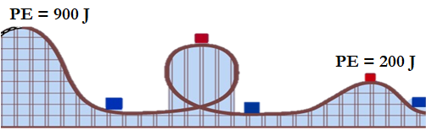
In the image to the right, a roller coaster has 900 J of potential energy at the highest point, and it is not moving at this point. The cart goes through a loop and over a hill.

What is the cart’s TME?

If the cart has 200 J of PE at the top of the second hill, how much KE does it have?

- A ball is rolling with 150 J of kinetic energy, and it slows down due to friction. After slowing down, it only has 110 J of kinetic energy. How much work did the friction force do on the ball?

- Ezekiel pushes a wagon with a force of 50 N for a distance of 50 meters in 10 seconds. Lauren pushes a wagon with a force of 25 N for 50 meters in 5 seconds.
  - Who performed more work?

  - Who used more power?

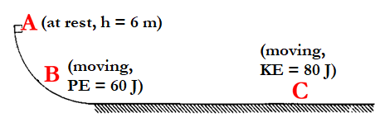
- A 4 kg block is released from rest at point (A). The block slides down a frictionless curved ramp past point (B) where it has 60 J of PE. It then slides along a flat, rough surface, where it begins to slow down.
  - What is the potential energy at point A?
  - What is the TME at point A?
  - What is the kinetic energy at point B?
  - What type of force did work to move the object from A to B?
  - How much work did friction do while the block was sliding across the rough surface up to point C?
  - If the distance is 5 m from the start of the rough surface to point C, how much friction did the box encounter over that distance?
  - How fast is the block moving at point C?
  - What type of energy was produced when the block slid over the rough surface and how much of this energy was produced?

