AP Physics Multiple Choice Practice – Torque

1. A uniform meterstick of mass 0.20 kg is pivoted at the 40 cm mark. Where should one hang a mass of 0.50 kg to balance the stick?   
(A) 16 cm (B) 36 cm (C) 44 cm (D) 46 cm (E) 54 cm

2. A uniform meterstick is balanced at its midpoint with several forces applied as shown below. If the stick is in equilibrium, the magnitude of the force X in newtons (N) is  
(A) 50 N (B) 100 N (C) 200 N (D) 300 N (E) impossible to determine without the weight of the stick

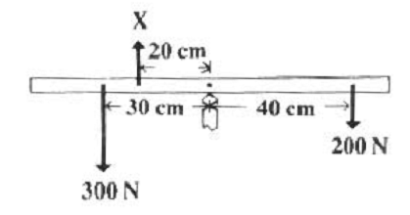

3. A door (seen from above in the figures below) has hinges on the left hand side. Which force produces the largest torque? The magnitudes of all forces are equal. C

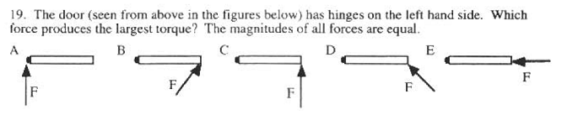4. A meterstick is supported at each side by a spring scale. A heavy mass is then hung on the meterstick so that the spring scale on the left hand side reads four times the value of the spring scale on the right hand side. If the mass of the meterstick is negligible compared to the hanging mass, how far from the right hand side is the large mass hanging.  
(A) 25 cm (B) 50 cm (C) 67 cm (D) 75 cm (E) 80 cm

5. A uniform meter stick has a 45.0 *g* mass placed at the 20 *cm* mark as shown in the figure. If a pivot is placed at the 42.5 *cm* mark and the meter stick remains horizontal in static equilibrium, what is the mass of the meter stick?

(A) 18.0 *g* (B) 45.0 *g* (C) 72.0 *g* (D) 120.0 *g* (E) 135.0 *g*

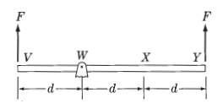

6. A massless rigid rod of length 3*d* is pivoted at a fixed point *W*, and two forces each of magnitude *F* are applied vertically upward as shown. A third vertical force of magnitude *F* may be applied, either upward or downward, at one of the labeled points. With the proper choice of direction at each point, the rod can be in equilibrium if the third force of magnitude *F* is applied at point

(A) *W* only (B) *Y* only (C) *V* or *X* only (D) *V* or *Y* only (E) *V, W,* or *X*

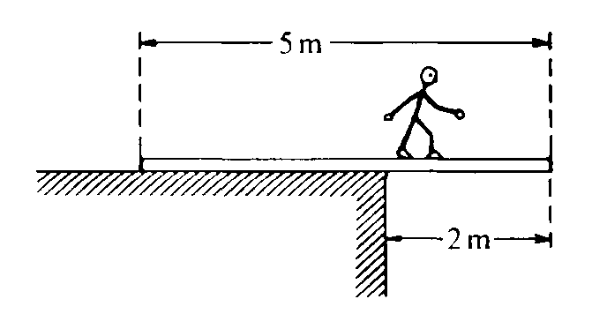

7. A 5‑meter uniform plank of mass 100 kilograms rests on the top of a building with 2 meters extended over the edge as shown. How far can a 50‑kilogram person venture past the edge of the building on the plank before the plank just begins to tip?

(A) 0.5 m (B) 1 m (C) 1.5 m ( D) 2 m

(E) It is impossible to make the plank tip since the person would have to be more than 2 meters from the edge of the building.

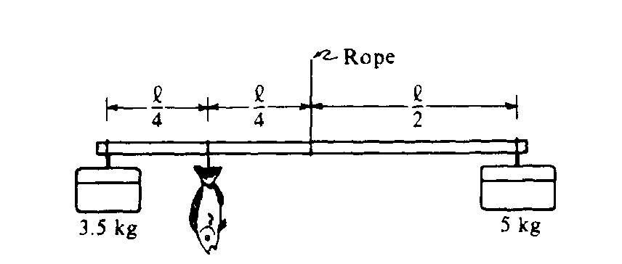

8. To weigh a fish, a person hangs a tackle box of mass 3.5 kilograms and a cooler of mass 5 kilograms from the ends of a uniform rigid pole that is suspended by a rope attached to its center. The system balances when the fish hangs at a point 1/4 of the rod’s length from the tackle box. What is the mass of the fish?

(A) 1.5 kg (B) 2 kg (C) 3 kg (D) 6 kg (E) 6.5 kg

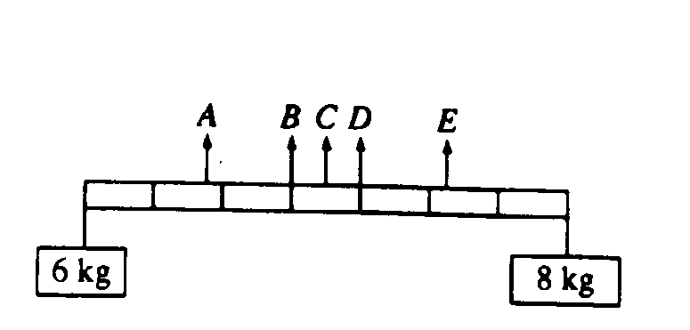

9. Two objects, of masses 6 and 8 kilograms, are hung from the ends of a stick that is 70 cm long and has marks every 10 cm, as shown. If the mass of the stick is negligible, at which of the points indicated should a cord be attached if the stick is to remain horizontal when suspended from the cord?  
(A) A (B) B (C) C (D) D (E) E