AP Physics Multiple Choice Practice – Dynamics

SECTION A – Linear Dynamics

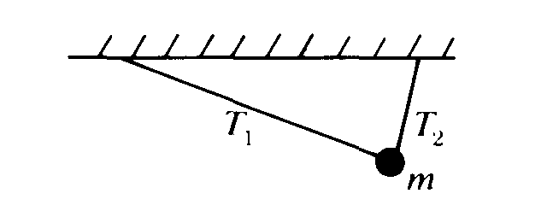

1. A ball of mass m is suspended from two strings of unequal length as shown above. The magnitudes of the tensions T1 and T2 in the strings must satisfy which of the following relations?

(A) Tl = T2 (B) T1 > T2 (C) T1 < T2 (D) Tl + T2 = mg (E) T1 – T2 = mg

Questions 2 – 3

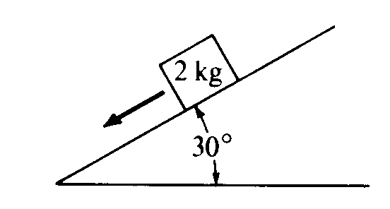

A 2‑kilogram block slides down a 30° incline as shown above with an acceleration of 2 meters per second squared.

2. Which of the following diagrams best represents the gravitational force W. the frictional force f, and the normal force N that act on the block?  
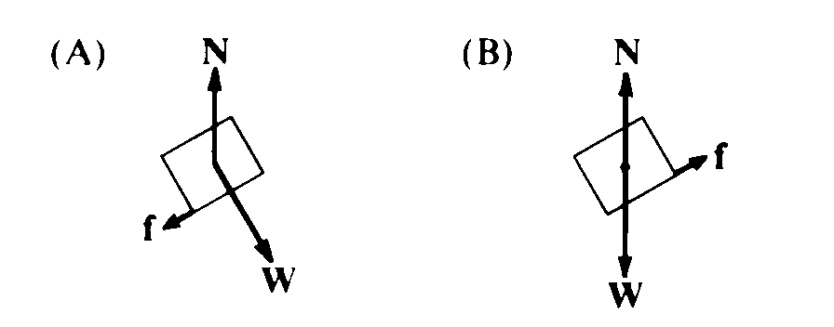 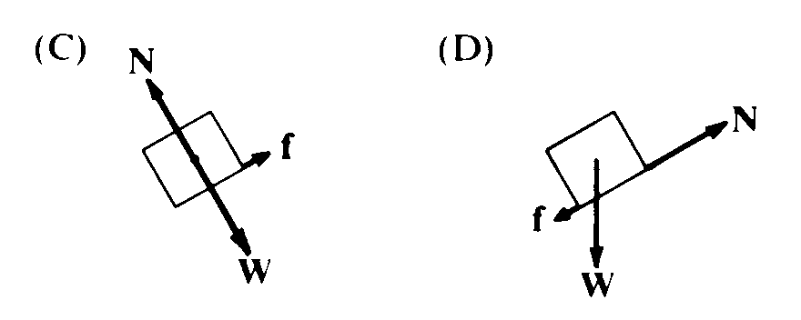 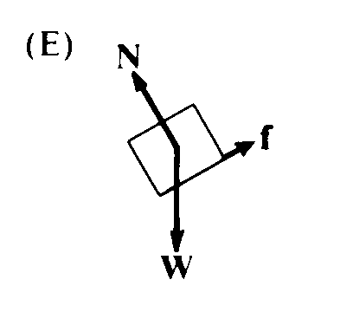

3. The magnitude of the frictional force along the plane is most nearly

(A) 2.5 N (B) 5 N (C) 6 N (D) 10 N (E) 16 N

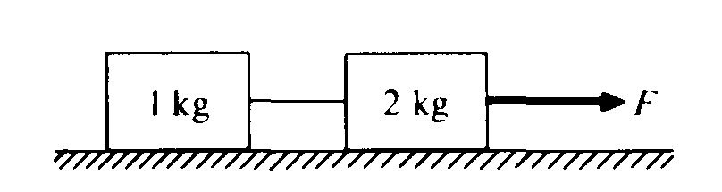

4. When the frictionless system shown above is accelerated by an applied force of magnitude the tension in the string between the blocks is (A) 2F (B) F (C) 2/3 F (D) ½ F (E) 1/3 F

5. A ball falls straight down through the air under the influence of gravity. There is a retarding force F on the ball with magnitude given by F = *bv*, where *v* is the speed of the ball and *b* is a positive constant. The magnitude of the acceleration, a of the ball at any time is equal to which of the following?  
(A) g – b (B) g – bv/m (C) g + bv/m (D) g/b (E) bv/m

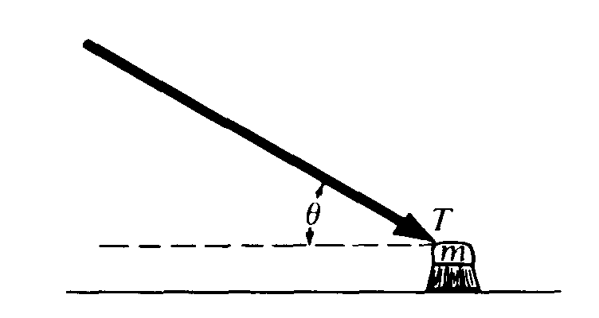

6. A push broom of mass m is pushed across a rough horizontal floor by a force of magnitude T directed at angle θ as shown above. The coefficient of friction between the broom and the floor is μ. The frictional force on the broom has magnitude  
(A) μ(mg + Tsinθ) (B) μ(mg – Tsinθ) (C) μ(mg + Tcosθ) (D) μ(mg – Tcosθ) (E) μmg

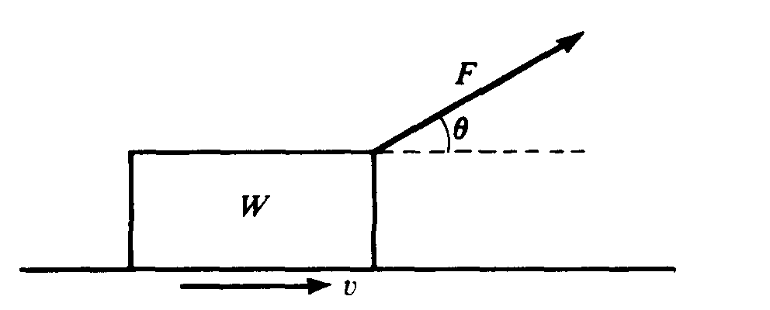

7. A block of weight W is pulled along a horizontal surface at constant speed v by a force F, which acts at an angle of θ with the horizontal, as shown above. The normal force exerted on the block by the surface has magnitude

(A) W – F cos θ (B) W – F sin θ (C) W (D) W + F sin θ (E) W + F cos θ

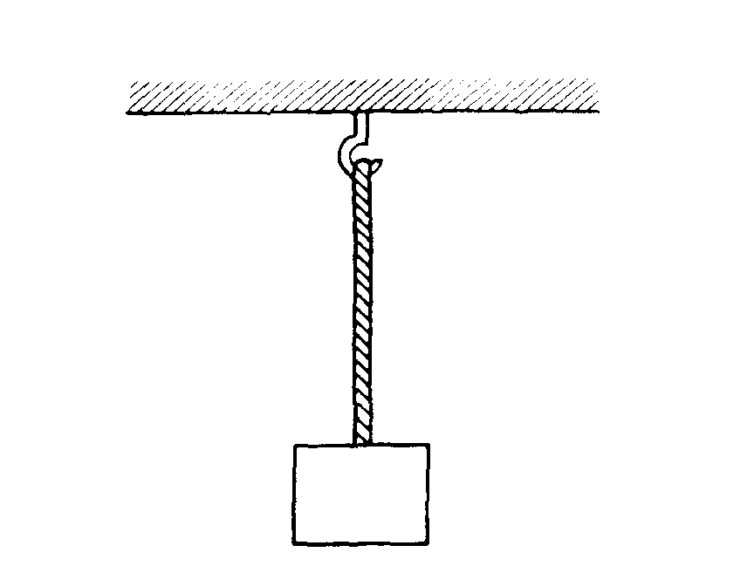

8. A uniform rope of weight 50 newtons hangs from a hook as shown above. A box of weight 100 newtons hangs from the rope. What is the tension in the rope?  
(A) 50 N throughout the rope (B) 75 N throughout the rope (C) 100 N throughout the rope   
(D) 150 N throughout the rope (E) It varies from 100 N at the bottom of the rope to 150 N at the top.

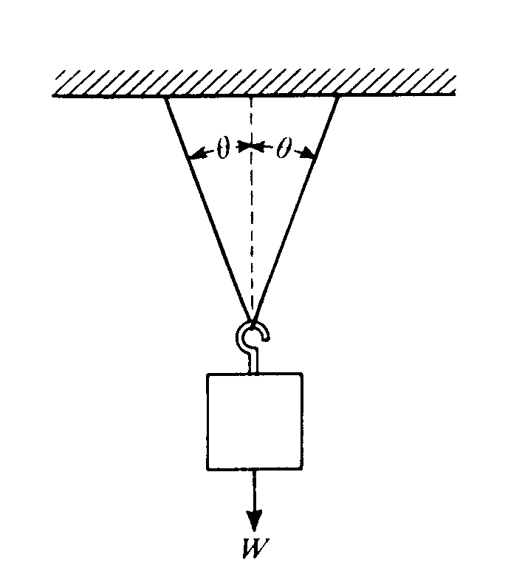

9. When an object of weight W is suspended from the center of a massless string as shown above, the tension at any point in the string is  
(A) 2Wcosθ (B) ½Wcosθ (C) Wcosθ (D) W/(2cosθ) (E) W/(cosθ)

\*10. An ideal spring obeys Hooke's law, F = –kx. A mass of 0.50 kilogram hung vertically from this spring stretches the spring 0.075 meter. The value of the force constant for the spring is most nearly

(A) 0.33 N/m (B) 0.66 N/m (C) 6.6 N/m (D) 33 N/m (E) 66 N/m

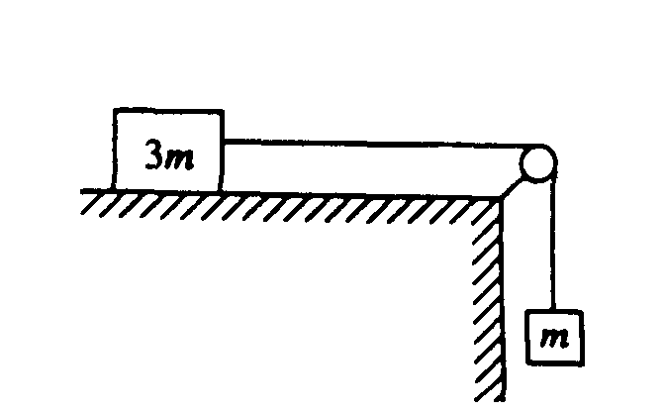

11. A block of mass 3m can move without friction on a horizontal table. This block is attached to another block of mass m by a cord that passes over a frictionless pulley, as shown above. If the masses of the cord and the pulley are negligible, what is the magnitude of the acceleration of the descending block?  
(A) Zero (B) g/4 (C) g/3 (D) 2g/3 (E) g

Questions 12 – 13

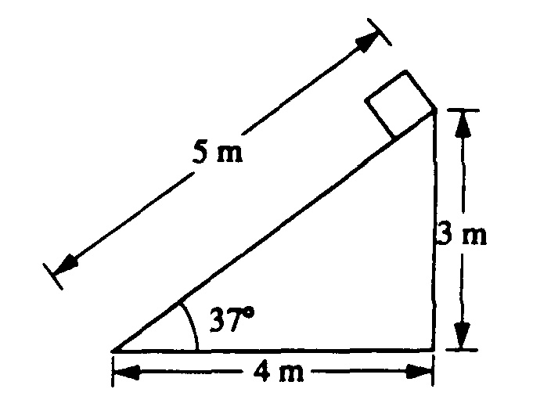

A plane 5 meters in length is inclined at an angle of 37°, as shown above. A block of weight 20 newtons is placed at the top of the plane and allowed to slide down.

12. The mass of the block is most nearly  
(A) 1.0 kg (B) 1.2 kg (C) 1.6 kg (D) 2.0 kg (E) 2.5 kg

13. The magnitude of the normal force exerted on the block by the plane is most nearly  
(A) 10 N (B) 12 N (C) 16 N (D) 20 N (E) 33 N

14. Three forces act on an object. If the object is in translational equilibrium, which of the following must be true?

I. The vector sum of the three forces must equal zero.

II. The magnitudes of the three forces must be equal.

III. All three forces must be parallel.

(A) I only (B) II only (C) I and III only (D) II and III only (E) I, II, and III

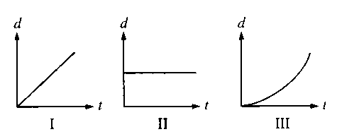

15. Three objects can only move along a straight, level path. The graphs above show the position *d* of each of the objects plotted as a function of time *t*. The sum of the forces on the object is zero in which of the cases?

(A) II only (B) III only (C) I and II only (D) I and III only (E) I, II, and III

\*16.For which of the following motions of an object must the acceleration always be zero?

I. Any motion in a straight line

II. Simple harmonic motion

III. Any motion in a circle

(A) I only (B) II only (C) III only (D) Either I or III, but not II   
(E) None of these motions guarantees zero acceleration.

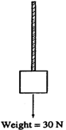

17. A rope of negligible mass supports a block that weighs 30 N, as shown above. The breaking strength of the rope is 50 N. The largest acceleration that can be given to the block by pulling up on it with the rope without breaking the rope is most nearly

(A) 6 m/s2 (B) 6.7 m/s2 (C) 10 m/s2 (D) 15 m/s2 (E) 16.7 m/s2

Questions 18 – 19

A horizontal, uniform board of weight 125 N and length 4 m is supported by vertical chains at each end. A person weighing 500 N is sitting on the board. The tension in the right chain is 250 N.

18. What is the tension in the left chain?

(A) 250 N (B) 375 N (C) 500 N (D) 625 N (E) 875 N

\*19. How far from the left end of the board is the person sitting?

(A) 0.4 m (B) 1.5 m (C) 2 m (D) 2.5 m (E) 3 m

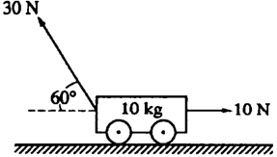

20. The cart of mass 10 kg shown above moves without frictional loss on a level table. A 10 N force pulls on the cart horizontally to the right. At the same time, a 30 N force at an angle of 60° above the horizontal pulls on the cart to the left. What is the magnitude of the horizontal acceleration of the cart?   
(A) 0.5 m/s2 (B) 1.6 m/s2 (C) 2.0 m/s2 (D) 2.5 m/s2 (E) 2.6 m/s2

21. An object of mass *m* is initially at rest and free to move without friction in any direction in the *xy*‑plane. A constant net force of magnitude *F* directed in the *+x* direction acts on the object for 1 s. Immediately thereafter a constant net force of the same magnitude *F* directed in the *+y* direction acts on the object for 1 s. After this, no forces act on the object. Which of the following vectors could represent the velocity of the object at the end of 3 s, assuming the scales on the x and y axes are equal.

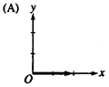 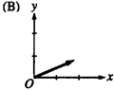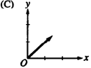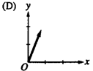 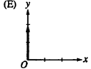

22. Two people are pulling on the ends of a rope. Each person pulls with a force of 100 N. The tension in the rope is:

(A) 0 N (B) 50 N (C) 100 N (D) 141 N (E) 200 N

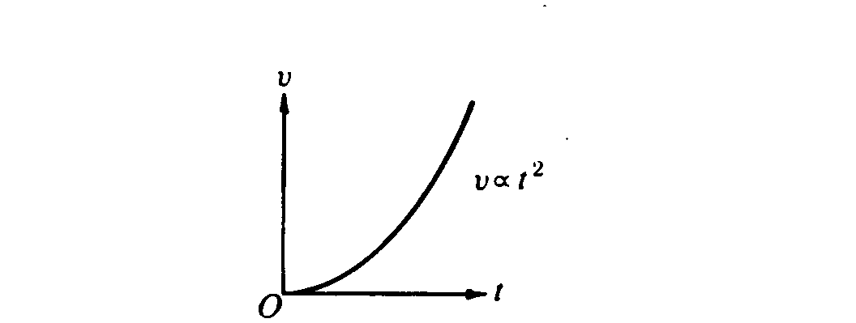

23. The parabola above is a graph of speed v as a function of time t for an object. Which of the following graphs best represents the magnitude F of the net force exerted on the object as a function of time t?



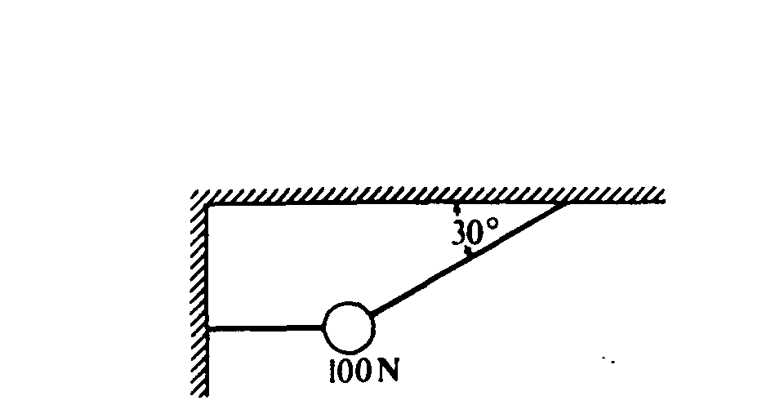

24. A 100‑newton weight is suspended by two cords as shown above. The tension in the slanted cord is

(A) 50 N (B) 100 N (C) 150 N (D) 200 N (E) 250 N

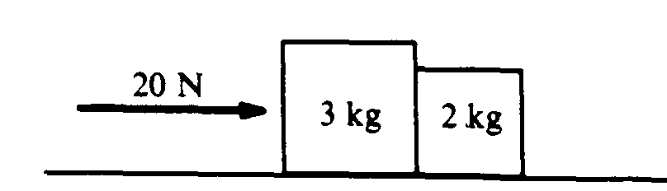

25. Two blocks are pushed along a horizontal friction­less surface by a force of 20 newtons to the right, as shown above. The force that the 2‑kilogram block exerts on the 3‑kilogram block is

(A) 8 newtons to the left (B) 8 newtons to the right (C) 10 newtons to the left   
(D) 12 newtons to the right (E) 20 newtons to the left

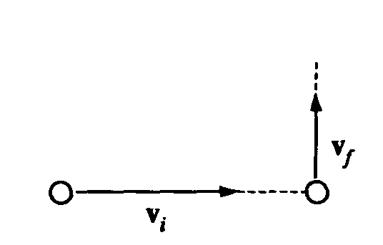

26. A ball initially moves horizontally with velocity vi, as shown above. It is then struck by a stick. After leaving the stick, the ball moves vertically with a velocity vf, which is smaller in magnitude than vi. Which of the following vectors best represents the direction of the average force that the stick exerts on the ball?

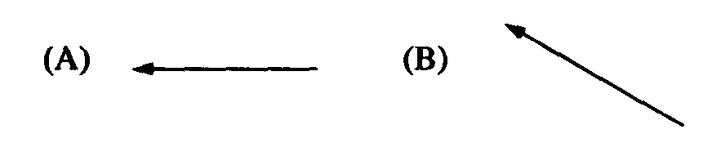 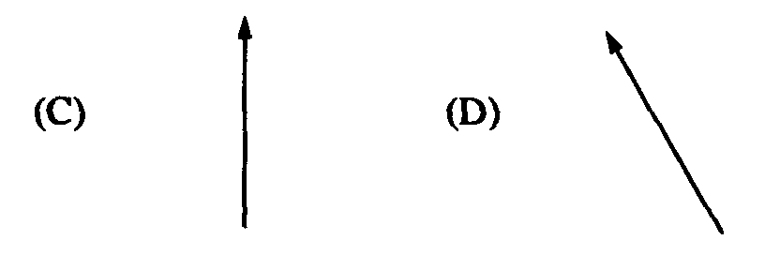 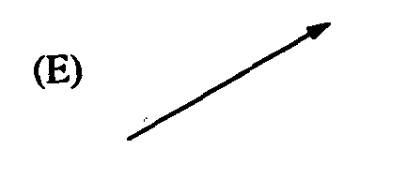

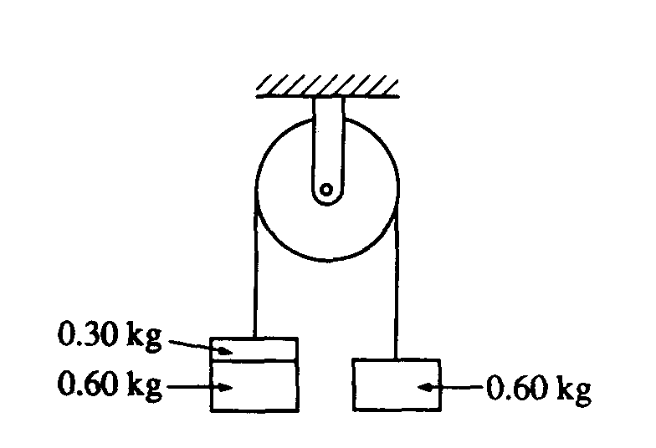

27. Two 0.60‑kilogram objects are connected by a thread that passes over a light, frictionless pulley, as shown above. The objects are initially held at rest. If a third object with a mass of 0.30 kilogram is added on top of one of the 0.60‑kilogram objects as shown and the objects are released, the magnitude of the acceleration of the 0.30‑kilogram object is most nearly

(A) 10.0 m/s2 (B) 6.0 m/s2 (C) 3.0 m/s2 (D) 2.0 m/s2 (E) 1.0 m/s2

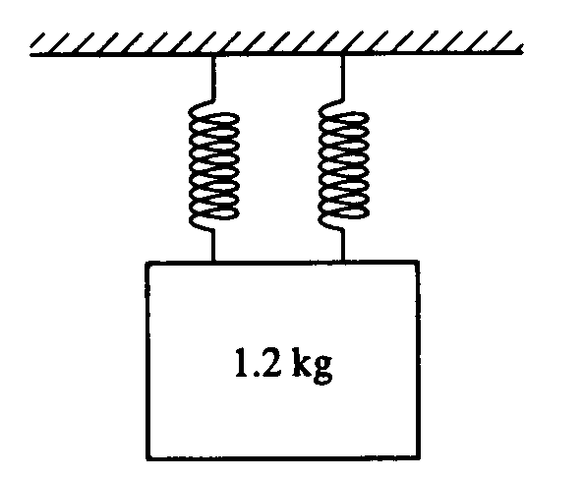

\*28. Two identical massless springs are hung from a horizontal support. A block of mass 1.2 kilograms is suspended from the pair of springs, as shown above. When the block is in equilibrium, each spring is stretched an additional 0.15 meter. The force constant of each spring is most nearly

(A) 40 N/m (B) 48 N/m (C) 60 N/m (D) 80 N/m (E) 96 N/m

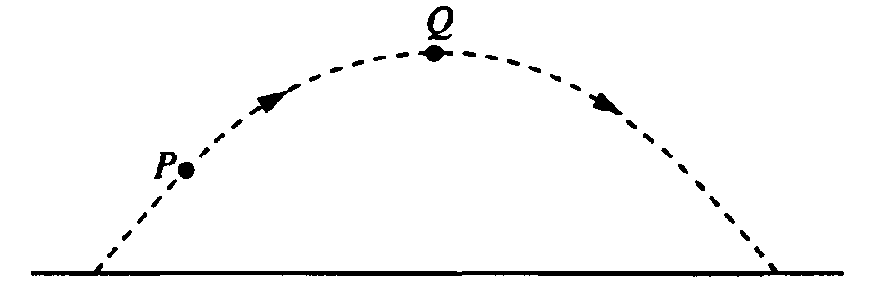

29. A ball is thrown and follows a parabolic path, as shown above. Air friction is negligible. Point Q is the highest point on the path. Which of the following best indicates the direction of the net force on the ball at point P ?

    

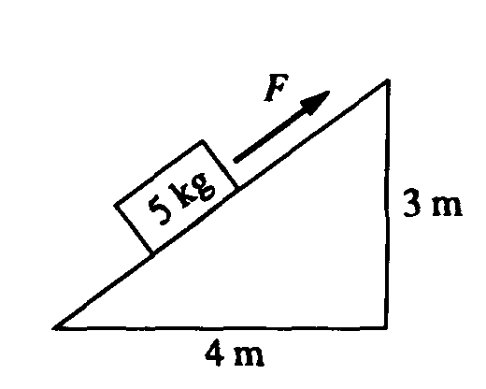

30. A block of mass 5 kilograms lies on an inclined plane, as shown above. The horizontal and vertical supports for the plane have lengths of 4 meters and 3 meters, respectively. The coefficient of friction between the plane and the block is 0.3. The magnitude of the force F necessary to pull the block up the plane with constant speed is most nearly   
(A) 30 N (B) 42 N (C) 49 N (D) 50 N (E) 58 N

Questions 31 – 32

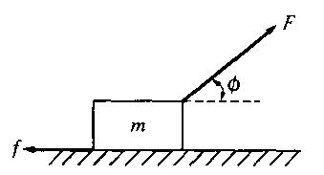

A block of mass m is accelerated across a rough surface by a force of magnitude F that is exerted at an angle φ with the horizontal, as shown above. The frictional force on the block exerted by the surface has magnitude *f*.

31. What is the acceleration of the block?   
(A) F*/m* (B) (Fcosφ)/m (C) (F–*f*)/*m* (D) (Fcosφ–*f*)/*m* (E) (Fsinφ–*mg*)/*m*

32. What is the coefficient of friction between the block and the surface?

(A) *f/mg* (B) *mg*/*f* (C) (*mg*–Fcosφ)/*f* (D) *f*/(*mg–*Fcosφ) (E) *f*/(*mg–*Fsinφ)



33. Three blocks of masses 3*m*, 2*m*, and*s* are connected to strings *A, B*, and *C* as shown above. The blocks are pulled along a rough surface by a force of magnitude *F* exerted by string *C*. The coefficient of friction between each block and the surface is the same. Which string must be the strongest in order not to break?

(A) *A* (B) *B* (C) *C* (D) They must all be the same strength.

(E) It is impossible to determine without knowing the coefficient of friction.

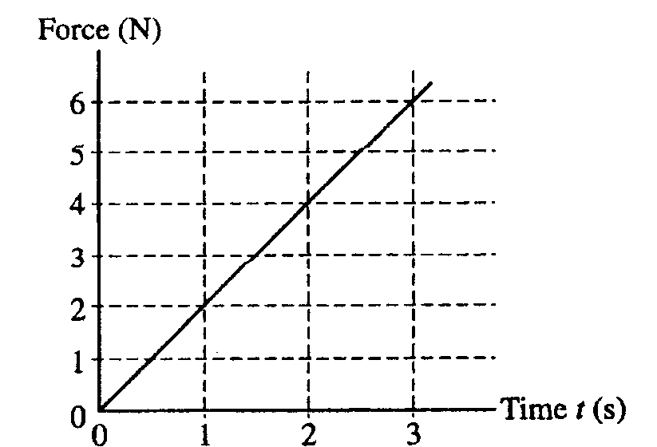

34. A block of mass 3 kg, initially at rest, is pulled along a frictionless, horizontal surface with a force shown as a function of time t by the graph above. The acceleration of the block at t = 2 s is

(A) 3/4 m/s2 (B) 4/3 m/s2 (C) 2 m/s2 (D) 8 m/s2 (E) 12 m/s2

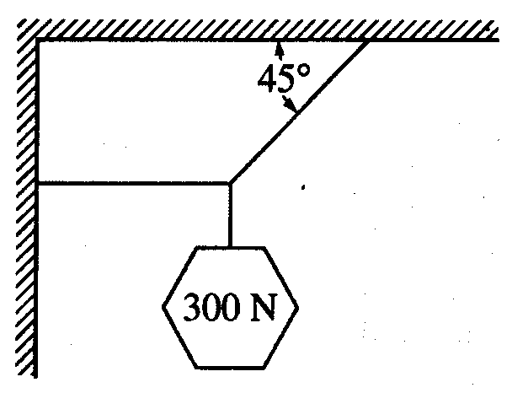

35. An object weighing 300 N is suspended by means of two cords, as shown above. The tension in the horizontal cord is

(A) 0 N (B) 150 N (C) 210 N (D) 300 N (E) 400 N

Questions 36 – 38

A small box is on a ramp tilted at an angle θ above the horizontal. The box may be subject to the following forces: frictional (*f* ) ,gravitational (*mg*), pulling or pushing (*FP*) and normal *(I)*. In the following free‑body diagrams for the box, the lengths of the vectors are proportional to the magnitudes of the forces.

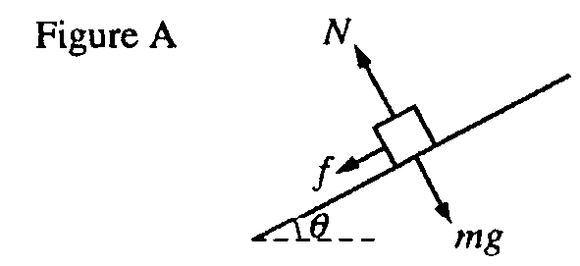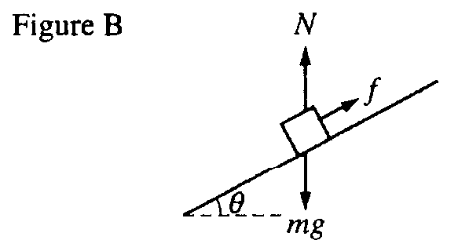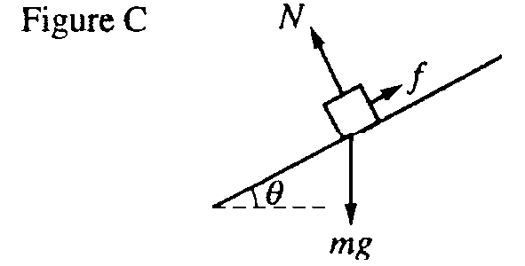

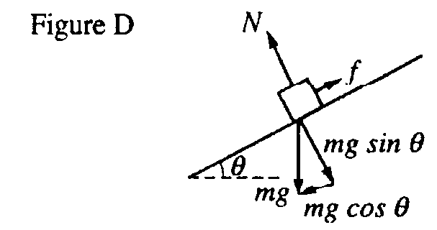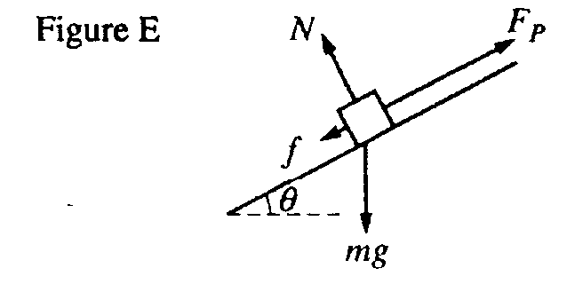

36. Which figure best represents the free‑body diagram for the box if it is accelerating up the ramp?

(A) Figure A (B) Figure B (C) Figure C (D) Figure D (E) Figure E

37. Which figure best represents the free‑body diagram for the box if it is at rest on the ramp?

(A) Figure A (B) Figure B (C) Figure C (D) Figure D (E) Figure E

38. Which figure best represents the free‑body diagram for the box if it is sliding down the ramp at constant speed?

(A) Figure A (B) Figure B (C) Figure C (D) Figure D (E) Figure E