**AP Physics Multiple Choice Practice – Kinematics**

**1. A car travels 30 miles at an average speed of 60 miles per hour and then 30 miles at an average speed of 30 miles per hour. The average speed the car over the 60 miles is**

**(A) 35 m.p.h. (B) 40 m.p.h. (C) 45 m.p.h. (D) 10 m.p.h. (E) 53 m.p.h.**

**Questions 2 – 4 relate to two particles that start at x = 0 at t = 0 and move in one dimension independently of one another. Graphs, of the velocity of each particle versus time are shown below**

**Particle A Particle B**

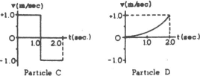

**2.0**

**1.0**

**1.0 2.0**

**2. Which particle is farthest from the origin at t = 2 seconds.**

**(A) A (B) B (C) they are in the same location at t = 2 seconds (D) They are the same distance from the origin, but in opposite directions (E) It is not possible to determine**

**3. Which particle moves with constant non-zero acceleration?**

**(A) A (B) B (C) both A and B (D) neither A nor B (E) It is not possible to determine**

**4. Which particle is in its initial position at t = 2 seconds?**

**(A) A (B) B (C) both A and B (D) neither A nor B (E) It is not possible to determine**

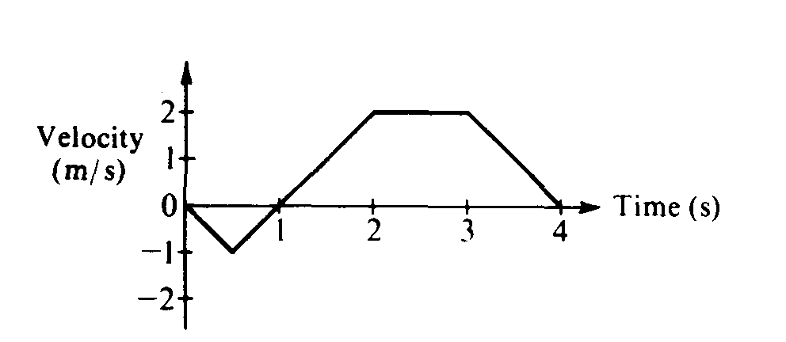

**5. The graph above shows the velocity versus time for an object moving in a straight line. At what time after**

**t = 0 does the object again pass through its initial position?**

**(A) Between 0 and 1 s (B) 1 s (C) Between 1 and 2 s (D) 2 s (E) Between 2 and 3 s**

**6. A body moving in the positive x direction passes the origin at time t = 0. Between t = 0 and t = 1 second, the body has a constant speed of 24 meters per second. At t = 1 second, the body is given a constant acceleration of 6 meters per second squared in the negative x direction. The position x of the body at t = 11 seconds is**

**(A) + 99m (B) + 36m (C) – 36 m (D) – 75 m (E) – 99 m**

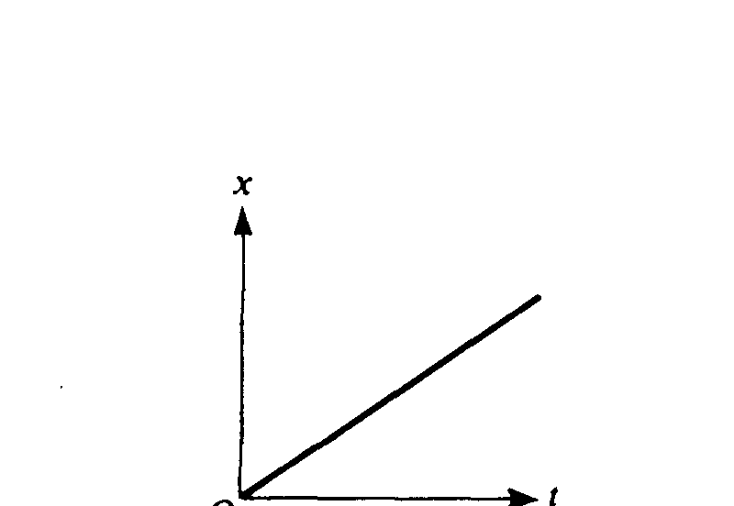

**7. The displacement, x, of an object moving along the x-axis is shown above as a function of time, t. The acceleration of this object must be   
(A) zero (B) constant but not zero (C) increasing (D) decreasing (E) equal to g**

**8. A 2‑kilogram block rests at the edge of a platform that is 10 meters above level ground. The block is launched horizontally from the edge of the platform with an initial speed of 3 meters per second. Air resistance is negligible. The time it will take for the block to reach the ground is most nearly   
(A) 0.3 s (B) 1.0 s (C) 1.4 s (D) 2.0 s (E) 3.0 s**

**9. A diver initially moving horizontally with speed v dives off the edge of a vertical cliff and lands in the water a distance *d* from the base of the cliff. How far from the base of the cliff would the diver have landed if the diver initially had been moving horizontally with speed 2v?  
(A) *d* (B) (C) *2d* (D) *4d* (E) can’t be determined without knowing the height of the cliff**

**10. A truck traveled 400 meters north in 80 seconds, and then it traveled 300 meters east in 70 seconds. The magnitude of the average velocity of the truck was most nearly**

**(A) 1.2 m/s (B) 3.3 m/s (C) 4.6 m/s (D) 6.6 m/s (E) 9.3 m/s**

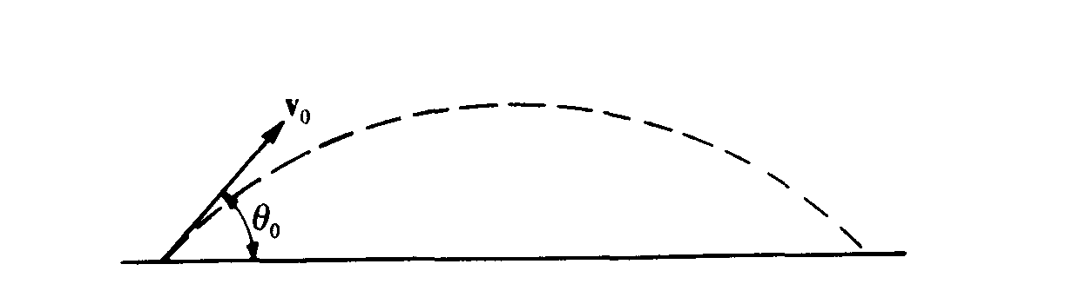

**11. A projectile is fired with initial velocity *v*o at an angle θ0 with the horizontal and follows the trajectory shown above. Which of the following pairs of graphs best represents the vertical components of the velocity and acceleration, v and a, respectively, of the projectile as functions of time t?  
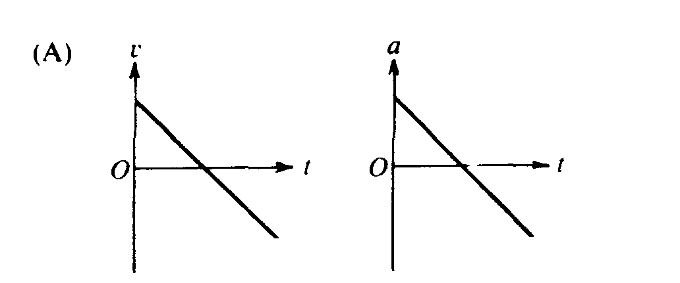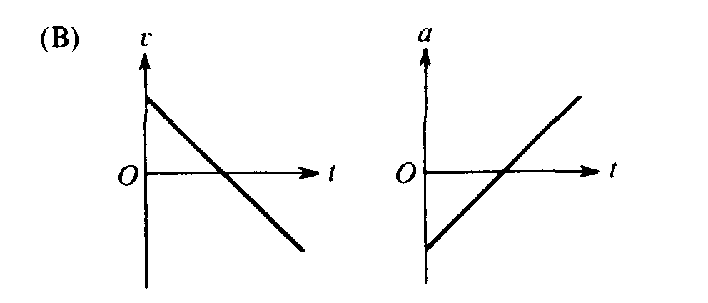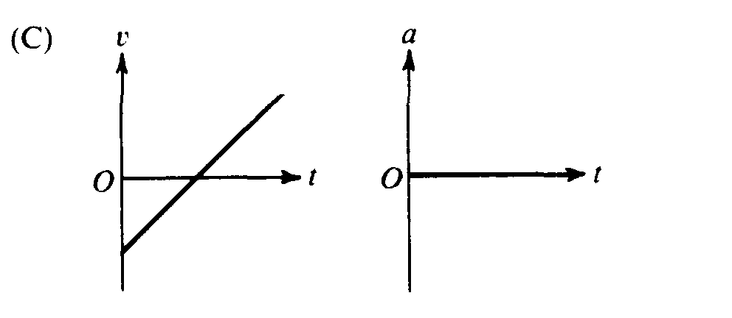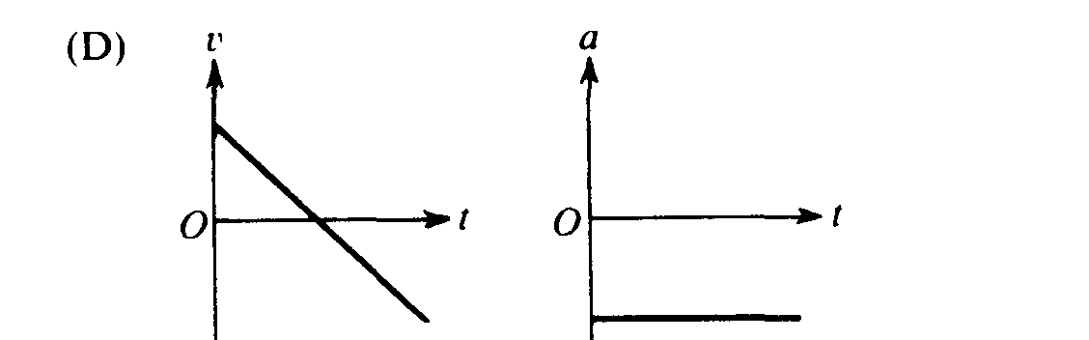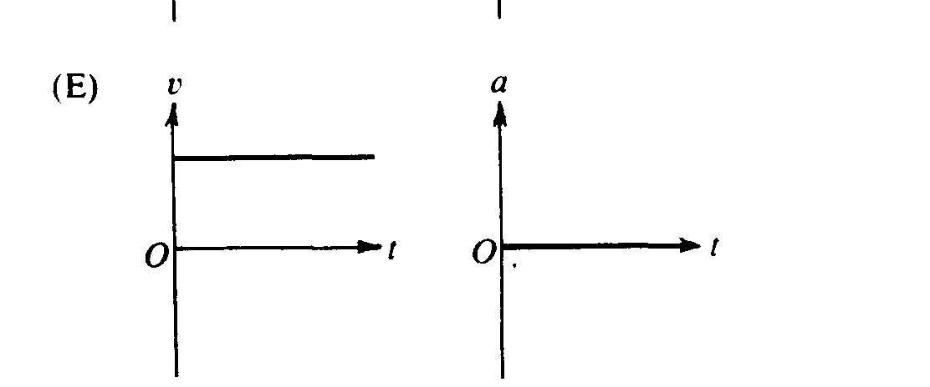**

**12. An object is released from rest on a planet that has no atmosphere. The object falls freely for 3.0 meters in the first second. What is the magnitude of the acceleration due to gravity on the planet?  
(A) 1.5 m/s2 (B) 3.0 m/s2 (C) 6.0 m/s2  (D) 10.0 m/s2 (E) 12.0 m/s2**

**Questions 13 – 14**

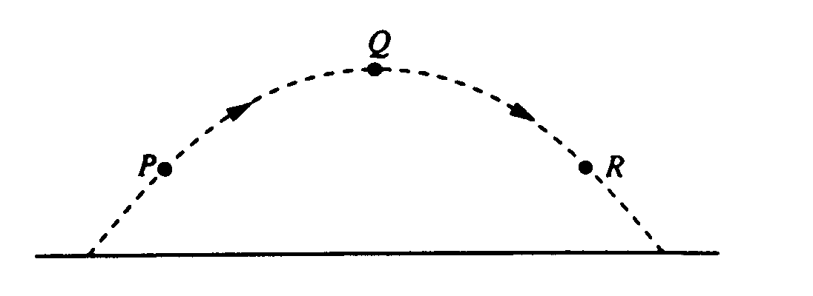

**A ball is thrown and follows the parabolic path shown above. Air friction is negligible. Point Q is the highest point on the path. Points P and R are the same height above the ground.**

**13. How do the speeds of the ball at the three points compare?  
(A) vP < vQ < vR (B) vR < vQ < vP (C) vQ < vR < vP (D) vQ< vP = vR (E) vP = vR < vQ**

**14. Which of the following diagrams best shows the direction of the acceleration of the ball at point P?  
(A)  (B)  (C)  (D)  (E) **

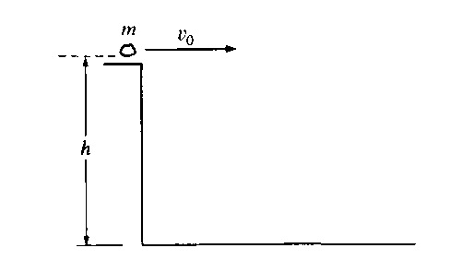

**15. A rock of mass *m* is thrown horizontally off a building from a height *h*, as shown above. The speed of the rock as it leaves the thrower’s hand at the edge of the building is *v0*.How much time does it take the rock to travel from the edge of the building to the ground?**

**(A)  (B)  (C)  (D)  (E) **

**16. A ball is thrown straight up in the air. When the ball reaches its highest point, which of the following is true?**

**(A) It is in equilibrium. (B) It has zero acceleration. (C)It has maximum momentum   
(D) It has maximum kinetic energy. (E) None of the above**

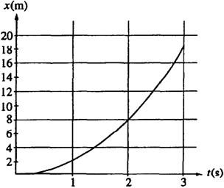

**17. The graph above represents position x versus time t for an object being acted on by a constant force. The average speed during the interval between 1 s and 2 s is most nearly**

**(A) 2 m/s (B) 4 m/s (C) 5 m/s (D) 6 m/s (E) 8 m/s**

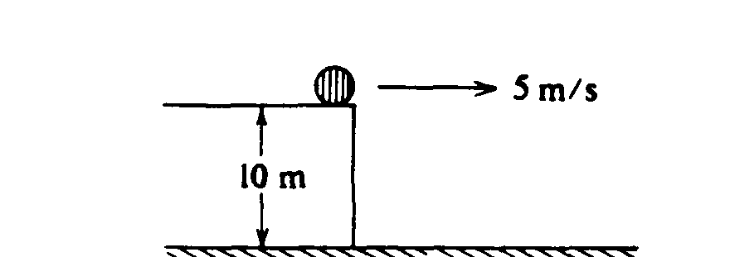

**18. An object slides off a roof 10 meters above the ground with an initial horizontal speed of 5 meters per second as shown above. The time between the object's leaving the roof and hitting the ground is most nearly**

**(A)  s (B) s (C)  s (D) 2 s (E)  s**

**Questions 19 – 20**

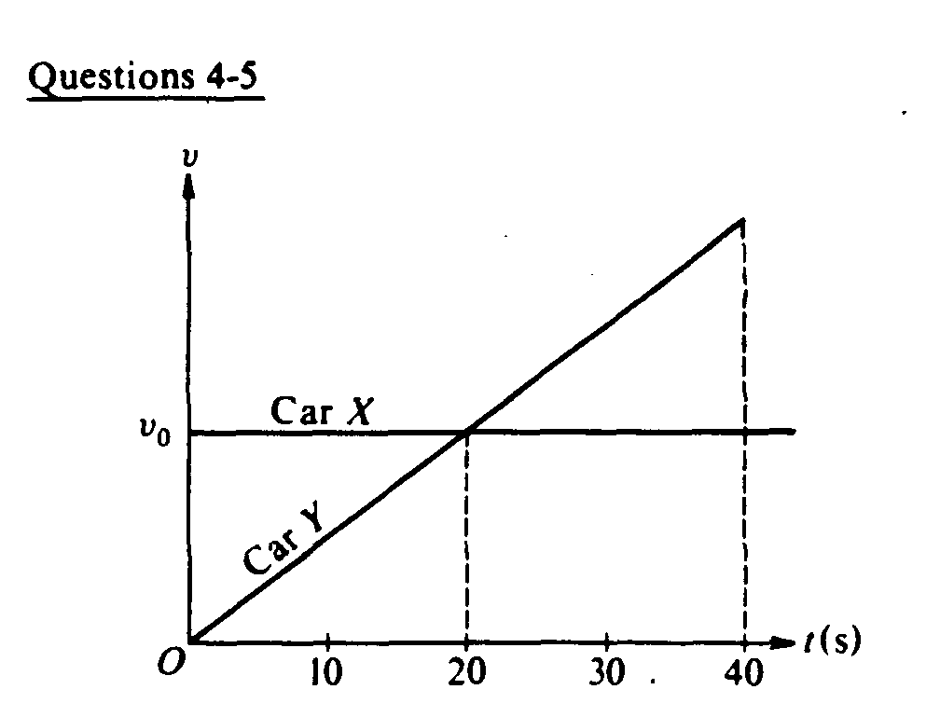

**At time t = 0, car X traveling with speed *v*0 passes car Y which is just starting to move. Both cars then travel on two parallel lanes of the same straight road. The graphs of speed *v* versus time t for both cars are shown above.**

**19. Which of the following is true at time t = 20 seconds?**

**(A) Car Y is behind car X. (B) Car Y is passing car X. (C) Car Y is in front of car X.**

**(D) Both cars have the same acceleration. (E) Car X is accelerating faster than car Y.**

**20. From time t = 0 to time t = 40 seconds, the areas under both curves are equal. Therefore, which of the following is true at time t = 40 seconds?**

**(A) Car Y is behind car X. (B) Car Y is passing car X. (C) Car Y is in front of car X.**

**(D) Both cars have the same acceleration. (E) Car X is accelerating faster than car Y.**

**21. Which of the following pairs of graphs shows the distance traveled versus time and the speed versus time for an object uniformly accelerated from rest?**

** **

**22. An object released from rest at time t = 0 slides down a frictionless incline a distance of 1 meter during the first second. The distance traveled by the object during the time interval from t = 1 second to t = 2 seconds is**

**(A) 1 m (B) 2 m (C) 3 m (D) 4 m (E) 5 m**

**23. Two people are in a boat that is capable of a maximum speed of 5 kilometers per hour in still water, and wish to cross a river 1 kilometer wide to a point directly across from their starting point. If the speed of the water in the river is 5 kilometers per hour, how much time is required for the crossing?**

**(A) 0.05 hr (B) 0.1 hr (C) 1 hr (D) 10 hr**

**(E) The point directly across from the starting point cannot be reached under these conditions.**

**24. A projectile is fired from the surface of the Earth with a speed of 200 meters per second at an angle of 30° above the horizontal. If the ground is level, what is the maximum height reached by the projectile?**

**(A) 5 m (B) 10 m (C) 500 m (D) 1,000 m (E) 2,000 m**

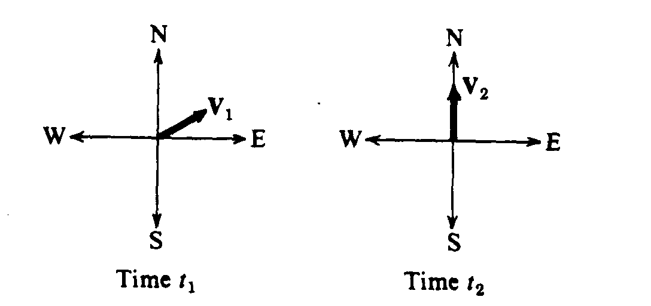

**25. Vectors V1 andV2 shown above have equal magnitudes. The vectors represent the velocities of an object at times *t1*, and *t2*, respectively. The average acceleration of the object between time *t1* and *t2* was**

**(A) zero (B) directed north (C) directed west (D) directed north of east (E) directed north of west**

**26. A rock is dropped from the top of a 45‑meter tower, and at the same time a ball is thrown from the top of the tower in a horizontal direction. Air resistance is negligible. The ball and the rock hit the level ground a distance of 30 meters apart. The horizontal velocity of the ball thrown was most nearly**

**(A) 5 m/s (B) 10 m/s (C) 14.1 m/s (D) 20 m/s (E) 28.3 m/s**

**27. In the absence of air friction, an object dropped near the surface of the Earth experiences a constant acceleration of about 9.8 m/s2. This means that the**

**(A) speed of the object increases 9.8 m/s during each second   
(B) speed of the object as it falls is 9.8 m/s**

**(C) object falls 9.8 meters during each second   
(D) object falls 9.8 meters during the first second only**

**(E) rate of change of the displacement with respect to time for the object equals 9.8 m/s2**

**28. A 500‑kilogram sports car accelerates uniformly from rest, reaching a speed of 30 meters per second in 6 seconds. During the 6 seconds, the car has traveled a distance of**

**(A) 15 m (B) 30 m (C) 60 m (D) 90 m (E) 180 m**

**\*29. At a particular instant, a stationary observer on the ground sees a package falling with speed v1 at an angle to the vertical. To a pilot flying horizontally at constant speed relative to the ground, the package appears to be falling vertically with a speed v2 at that instant. What is the speed of the pilot relative to the ground?**

**(A) v1 + v2 (B) v1 – v2 (C) v2 – v1 (D)  (E)**

**30. An object is shot vertically upward into the air with a positive initial velocity. Which of the following correctly describes the velocity and acceleration of the object at its maximum elevation?**

**Velocity Acceleration**

**(A) Positive Positive**

**(B) Zero Zero**

**(C) Negative Negative**

**(D) Zero Negative**

**(E) Positive Negative**